**Dear Supervising Tutors and PhD students,**

The Individualized curriculum (Individualized study plan, ISP) is prepared by the students in co-operation with their Supervising Tutor in the Study Information System (thereinafter SIS). This obligation is specified in the [Study and Examination Regulations](https://cuni.cz/UKEN-726.html), Part III. Article 10 General Provisions for Doctoral Study, paragraph 6 and is also specified in the **Rules for Organization of Studies at the First Faculty of Medicine.**

The deadlines for establishing the ISP are **mandatorily** set by the[**Dean's measure no. 17/2024**](https://www.lf1.cuni.cz/172024-kterym-se-stanovi-termin-predlozeni-individualniho-studijniho-planu-a-rocniho-hodnoceni-pro-studenty-doktorskych-studijnich-programu-v-akademickem-roce-202425),*which sets the deadline for the submission of the individual study plan and the annual evaluation for students of doctoral programs in the academic year 2024/2025.*

**The student is obliged to submit his/her individual study plan via the electronic information systém (SIS) to the supervisor; if he/she fails to do so by the deadline set by the Dean's measure, he/she has not fulfilled the requirements set by the Code of Study and Examination of Charles University and his/her studies will be terminated.**

**Terms to establish the** **ISP** for DSP II are provided as follows:

|  |  |
| --- | --- |
| **Proposal of the dissertation topic by the supervisor,**  **creation of the ISP by the student** | **20th March 2025** |
| **Submission of the ISP by the supervisor to the Subject Area board** | **31st March 2025** |
| **Approval of the ISP by the Subject Area board** | **30th April 2025** |

List of measures taken by the Dean to compile the ISP

* [Dean´s measure 17/2024](https://www.lf1.cuni.cz/172024-kterym-se-stanovi-termin-predlozeni-individualniho-studijniho-planu-a-rocniho-hodnoceni-pro-studenty-doktorskych-studijnich-programu-v-akademickem-roce-202425),which sets the deadline for the submission of the individual study plan and the annual evaluation for students of doctoral programs in the academic year 2024/2025.
* [Dean´s measure 17/2022](https://www.lf1.cuni.cz/file/98053/opd-17-22.pdf), Determination of details for the preparation of the Individual Study Plan in doctoral study programs

doc. MUDr. Lukáš Zlatohlávek, Ph.D. – Vice-Dean for Doctoral Studies

Bc. Bohdana Frantíková – head of the Department of Science

**GUIDELINES FOR CREATION OF INDIVIDUALIZED CURRICULA (ISP)**

**When creating the curriculum (ISP), the following sequence of steps must be observed:**

(a) the Supervising Tutor announces the topic of the thesis in SIS and allots the topic to the PhD student,

(b) the student establishes the ISP, in co-operation with the Supervising Tutor develops a procedure in the preparation of the dissertation, including the stages of the research work, completes the course of studies and the overview of duties. Deadlines will be set for all parts of the Individual Study Plan. **Details for the preparation of the Individual Study Plan are set out in the** [**Dean's measure no. 17/2022**](https://www.lf1.cuni.cz/file/98053/opd-17-22.pdf).

(c) the Supervising Tutor approves the proposed ISP and forwards it to the Subject Area Board for assessment and approval

Content

1. Logging in for SIS 1

For Students 1

For supervising tutor 1

2. Allotting the topic of the dissertation thesis by the Supervising Tutor 1

3. Creating of the ISP by the student 1

a) Establishing the ISP 1

b) Dissertation thesis and the course of preparation of the thesis (and research schedule): 1

c) Dissertation defence 1

d) Course of study 1

e) List of duties 1

How to technically specify Courses obligations. 1

f) Forwarding the plan to the Supervising Tutor 1

4. Approval of the ISP by the Supervising Tutor 1

Annex 1a: Doctoral study programs in the field of Biomedicine 1

Biochemistry and Pathobiochemistry 1

Biology and Cell Biology 1

Biomedical Informatics 1

Developmental and Cell Biology 1

Experimental Surgery 1

Human Physiology and Pathophysiology 1

Imaging Methods in Medicine 1

Immunology 1

Medical Biophysics 1

Microbiology 1

Molecular and Cell Biology, Genetics and Virology 1

Neurosciences 1

Pharmacology and Toxicology 1

Preventive Medicine and Epidemiology 1

Subjects/courses for the doctoral study programs in the field of Biomedicine 1

Annex 1b: Subjects for other doctoral study programs (apart from Biomedicine) 1

Addiction: Specialization in Health Care 1

Bioethics 1

Medical Psychology and Psychopathology 1

History of medicine 1

Experimental and clinical oncology 1

Nutritional and Metabolic Sciences 1

Parasitology 1

Cardiovascular Science 1

# 1. Logging in for SIS

## For Students

At the address <https://is.cuni.cz/studium> you log in for SIS with your CAS login and password.

*User name* – the user name can be the personal identification number (printed below the photograph on the student ID card) or the CAS (Charles University Central Authentication Service) login. [An application](https://is.cuni.cz/studium/loginy/index.php/?lang=en) is available to find your login details by entering your personal ID number.

Password – this is assigned by CAS; for more details, see [here](https://cuni.cz/UKEN-134.html#4).

[Card Service Centres](https://cuni.cz/UKEN-135.html)

## For supervising tutor

At <https://is.cuni.cz/studium> you log in to SIS with your CAS login and password.

For thesis submission, ISP approval (and evaluation) supervisors use the role **Teacher (incl. PhD tutors)** assigned to the First Faculty of Medicine. If you have not been allotted the role of the **Teacher (incl. PhD tutors),** in Czech “učitel (i školitel) PhD”, at the First Faculty of Medicine, please contact Mrs. Marie Machová, [marie.machova@lf1.cuni.cz](mailto:marie.machova@lf1.cuni.cz)

For detailed information on logging into the SIS and how to obtain a valid CAS password, see: <https://cuni.cz/UKEN-134.html>.

# 2. Allotting the topic of the dissertation thesis by the Supervising Tutor

After logging in for the SIS, choose the application https://is.cuni.cz/teststud/img/dipl_uc.gif **Student thesis**. Supervising Tutors enter the thesis in the role **Teacher (incl. PhD tutors)**.

Further, choose the menu **New thesis** and fill in particularly the following items (see Fig. 1). It is not recommended to fill in the annotation of the thesis, as the data entered here are freely accessible at the internet (and can be searched out), unlike the details specified within the application ISP:

• **Topic/Title of thesis** – in ISP, the title is entered in the space Topic of the thesis at the moment it is allotted to the student as binding (so check on any possible misprints at once). Therefore, as the thesis is allotted to the student as binding, the current title of the thesis is copied in the space Topic of the thesis and will not be changed later. The title of the thesis can be adapted throughout the course of studies (following an approval by the Subject Area Board). On establishment of an annual evaluation, the current title of the thesis is always entered, while the original one is preserved in the plan (curriculum). Do not forget to fill in the English version as well.

• **Thesis announced in academic year** – the current academic year has been **preselected** for you

• **Language of thesis** – it is recommended to fill this in as well; it can be changed later if needed

• **Thesis type** – dissertation thesis

• **Department** – always **preselected** depending on the user logged in

• **Thesis subject area** – it is recommended to fill in (study programme)

• **Supervisor** – is **preselected**

• **Applicant** – choose the student after clicking on the magnifier

• **Advisors** – please do not fill in, the consultant is approved by the OR on the basis of the student's request

• **Save** - the button is at the very bottom of the page

• Once saved, click the ***Assign*** button on the next page (in the middle of the page - see printscreens below). **This will assign the thesis to the student.**

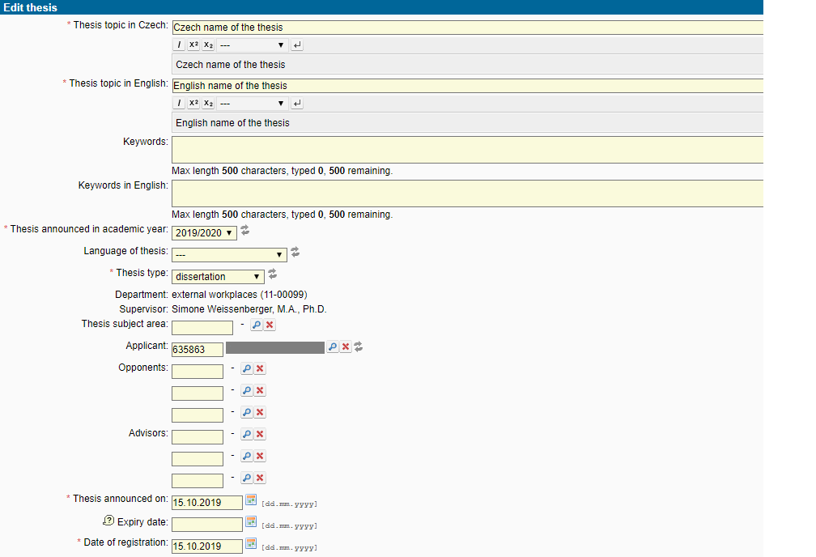

Fig. 1: Choice of the student and matching him/her to the thesis

Do not forget to enter any changes in the database – please find the button **Save** at the bottom of the page.

The data can be modified or corrected after choosing. Edit thesis from the options in the lower part of the window (Fig. 2 – green arrow).

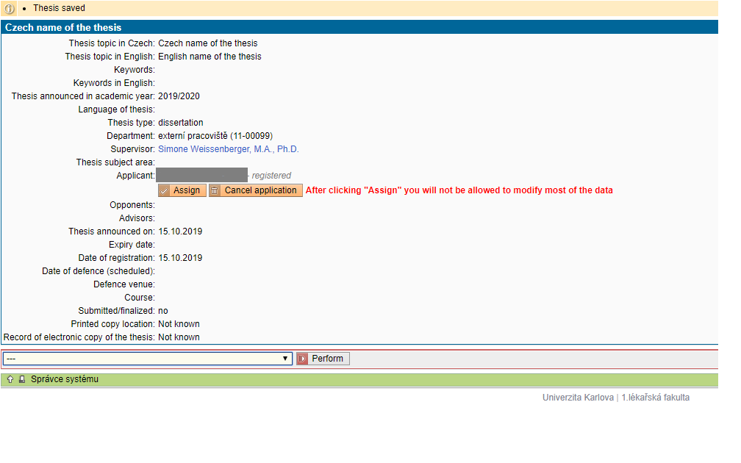

Fig. 2: Editing a dissertation thesis, Binding allotting of the thesis.

Having checked whether the Type of a thesis, Thesis announced in academic year, Supervisor and Researcher are filled in correctly, the thesis is allotted by a click on **Assign** (Fig. 2 – red arrow). The above items cannot then be changed and allotting the thesis to the student can only be cancelled by the study registrar. For any following steps it is essential that the thesis is allotted to the student. In the list of papers/theses, the date of allotment of the thesis to the student is shown in the column **Date of assignment.**

The data can be added or corrected by selected „Edit thesis“ from the menu at the bottom of the window (Fig. 4 – green arrow).

# 3. Creating of the ISP by the student

## a) Establishing the ISP

After logging in to the SIS, students choose the application  **Individual study plan for PhD students**. If the student has not been registered for the dissertation thesis, a red cross will appear (see the upper part of Fig. 3). After the thesis is allotted to the student as binding, the icon will change to Založit nový plán (the lower part of Fig. 3).

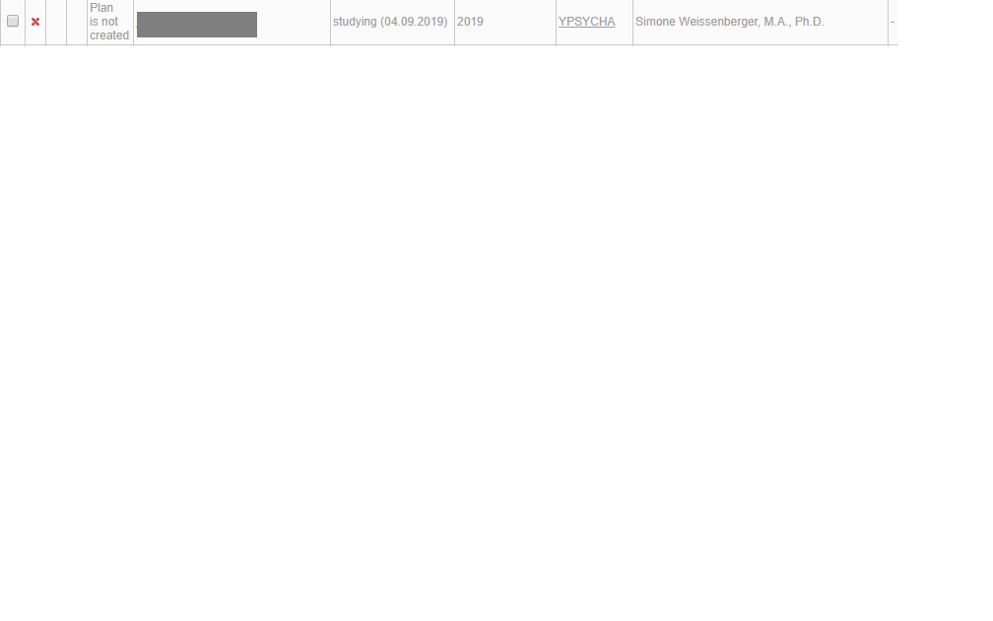

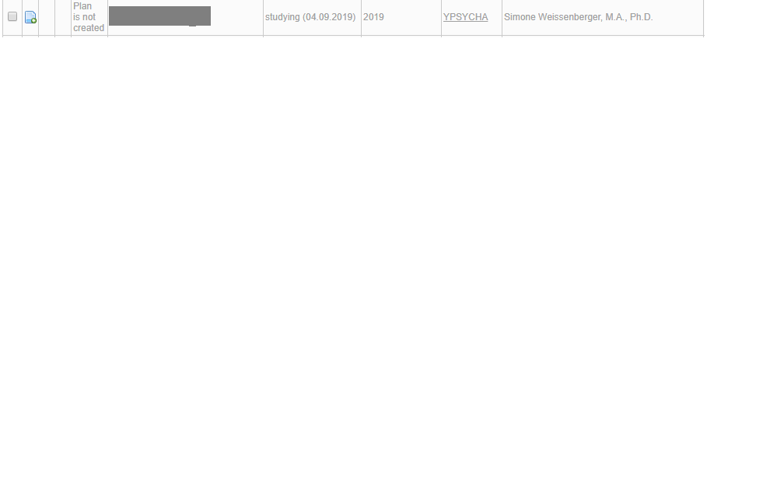

Fig. 3: Establishing the study plan (curriculum)

After a click on the icon Založit nový plán, the detail of the established ISP will appear. In the header, all basic information about the student, chairperson of the Subject Area Board, supervising tutor, consulting tutor and state of the curriculum is clearly displayed. The details will appear after a click on the button “plus” in the respective part (Fig. 4 – green arrow).

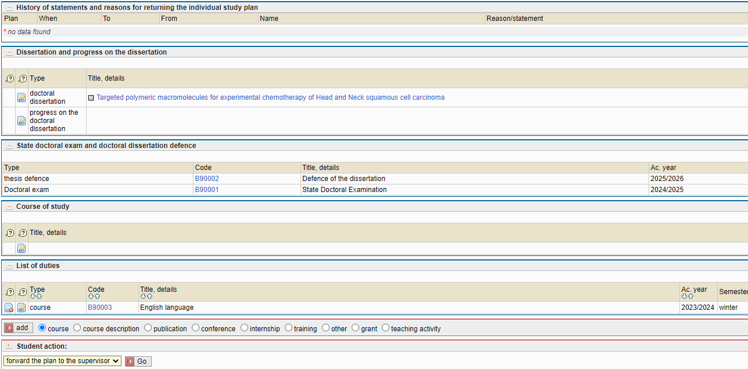

Fig. 4: Detail of the study plan (curriculum) and its parts

## b) Dissertation thesis and the course of preparation of the thesis (and research schedule):

Within this part of the ISP, the thesis allotted is displayed, and below, after a click on the editing icon [Upravit záznam o práci](https://is.cuni.cz/studium/dipl_uc/index.php?id=b99db339753c1ad3b7260cfc871736c1&tid=3&do=xakce&akce=editovat&did=153504&kam=seznam) in the line with the title of the dissertation thesis, the student can enclose an annotation (recommended, but compulsory for the students of the Subject Area Board Human physiology and pathophysiology).

By clicking on the edit icon [Upravit záznam o práci](https://is.cuni.cz/studium/dipl_uc/index.php?id=b99db339753c1ad3b7260cfc871736c1&tid=3&do=xakce&akce=editovat&did=153504&kam=seznam) in the line Progress on the doctoral dissertation the student fills in the planned procedure of preparation of the dissertation thesis for each academic year until the dissertation defence (see fig. 4 – red arrow). The course of the preparation of the dissertation must include also the schedule of the research work, giving the details for each year of study within the standard period of study, in the form of detailed description of very specific activities related to the work, including the deadline for completion of each stage, it must be clear what part of research work must be completed in each year.

An example of the d**issertation preparation process** and research **timeline**:

***Note: The Subject Area Board Experimental surgery*** requires a specific form of outline[1], which must be completed in the dissertation progress section.

## c) Dissertation defence

The State Doctoral Examination (SDE) is not a part of the studies after the amendment to the Higher Education Act comes into force, the colloquial examination will replace the SDE. The dissertation defence is scheduled for the final year of the standard period of study.

## d) Course of study

The student indicates his/her plan of study (fig. 4 – black arrow) by year within the standard period of study (4 years).

**Example of the course of study:**

## e) List of duties

#### Courses that are required by the accreditation of a given study program (SP). If your SP requires specific courses, they are already automatically entered in the Course of study [2].

#### Courses that are not required by the accreditation of the degree program but that are required electives.

If your SP does not require specific courses, but only a certain number of courses, it is up to you to select and add the required number of courses to the ISP.

#### English language.

English language is an obligatory subject for all students. In the Course of study according to the  [Dean's measure no. 17/2022](https://www.lf1.cuni.cz/file/98053/opd-17-22.pdf) English language is automatically listed in the 2nd year of study, but the fulfillment can be changed to the 1st year of study. You can edit the academic year by clicking on the editing icon [Upravit záznam o práci](https://is.cuni.cz/studium/dipl_uc/index.php?id=b99db339753c1ad3b7260cfc871736c1&tid=3&do=xakce&akce=editovat&did=153504&kam=seznam) at the beginning of the line for subject.

**The deadline for fulfillment of courses are set by**  [Dean's measure no. 17/2022](https://www.lf1.cuni.cz/file/98053/opd-17-22.pdf) **as follows:**

* In the first (1.) year of study at least one of the compulsory professional courses published at: <https://www.lf1.cuni.cz/biomedicina> and <https://www.lf1.cuni.cz/doktorske-studijni-programy-ostatni> is planned for the ISP, always under the name of the study program.
* No later than in the second (2.) year of study English language and at least one other professional course are planned, if the accreditation of the study program stipulates a higher number of compulsory or elective courses, they are planned for each year of the standard period of study according to the accreditation, if the accreditation does not specify a specific year of fulfillment, the courses are distributed evenly in the student's study load.

#### Includes planned publications, internships abroad and other duties as appropriate:

* Planned publications (indicate each of the planned publications separately, a general title is sufficient, e.g. „Publication 1“ etc. according to the number required by the accreditation and according to the Dean's measure no. 17/2022 the first publication will be scheduled no later than by the end of the 3rd year of studies).
* Internship – is a mandatory part of the ISP if required by the Board of the Field, however it is also an optional component that becomes mandatory upon approval of the ISP.
* Any other duties or obligations (grants, conferences, teaching activities, etc.).

### How to technically specify Courses obligations.

Courses, that you will complete during your studies are added as „course“ or „course description“ in the List of duties (see instructions below).

**Courses (subjects)** (Fig. 4 – blue arrow): – these are finished by an exam, a course credit (e.g. through a certificate gained), colloquium etc.; they will have their counterparts in the subjects entered in the SIS in the “Student” program and after passing them it will be possible to “match” them within the annual evaluation. These are, above all, the subjects that have been found in the SIS and have been marked with a code; codes of the subjects at the First Faculty of Medicine that are primarily designated for doctorands begin in B9XXXX.

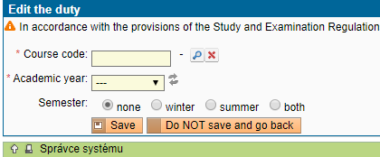

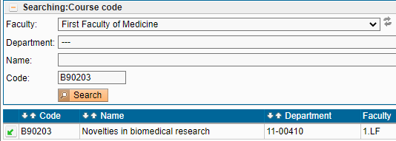

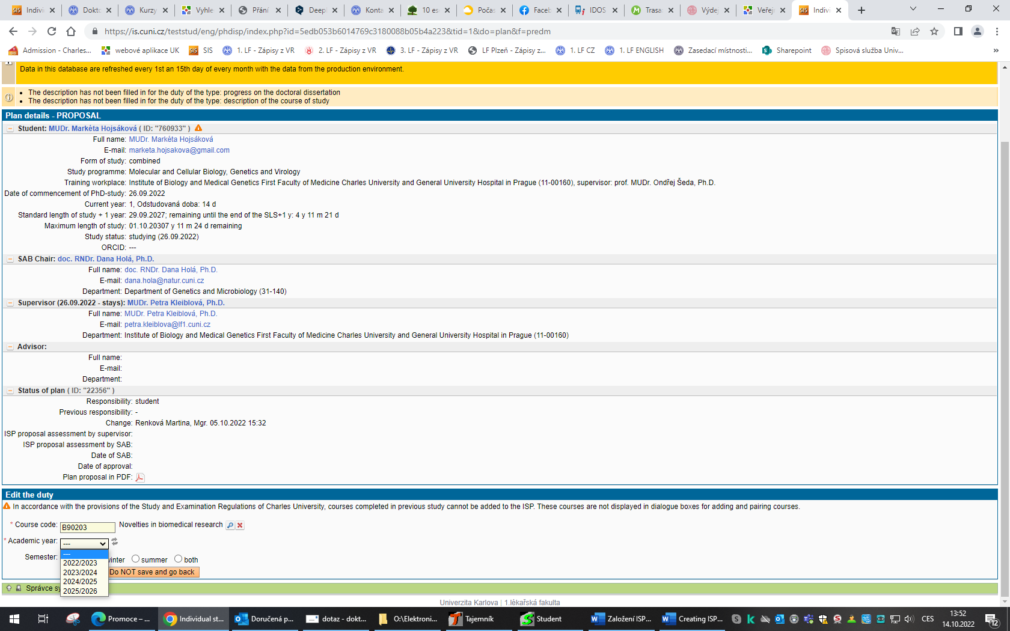

Fig. 5a: [**List of duties**](https://is.cuni.cz/teststud/eng/phdisp/index.php?id=d78a07cddd15b50d922ab3aa64053aa7&tid=3&do=plan&f=detail_isp&plid=15905#isp_href_povinnosti_parrent) – Course – searching for a subject with an allotted code

**Course description** (Fig. 4 – blue arrow): – a special subject or similar assignment that is not found in the offer by the SIS UK (e.g. subjects taught beyond Charles University, special courses finished with gaining a certificate). After presenting a proof of passing at the Department of Science and Research and International Relations of First Faculty of Medicine, it will be allotted a code by the Registrar. We ask you to kindly enter more details about this type of subject in the frame “Refinement of duty”: the exact title of the subject, title of the subject in English, subject code (if it exists and you know it), language of tuition, university (or equivalent school), faculty and the guarantor unit, teacher or examiner of the subject (if known), semester when taught (if known), way of examination (course credit / exam).

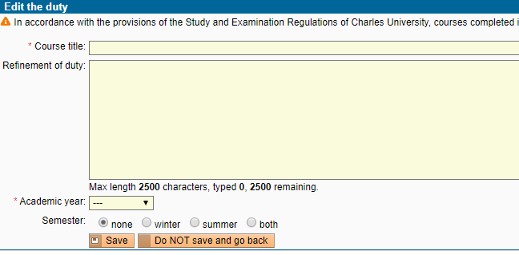

Fig. 5b: List of duties – **Course description** – a subject without a code, as a rule beyond Charles University

## f) Forwarding the plan to the Supervising Tutor

After finishing the creation of the plan, the draft ISP must be forwarded to the Supervising. In the roller menu in the lower part of the screen, the option **Forward the plan to the Supervisor** must be chosen and then the Execute button pressed (Fig. 6).

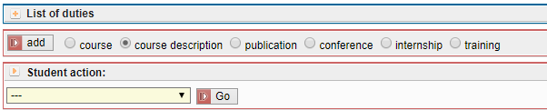

Fig. 6: Forwarding the plan to the Supervising Tutor

The Supervising Tutor will be informed through an automatically generated e-mail that his doctorand’s plan is ready for the check. He may ask the student to adjust and add some details of the plan. In such a case, too, the student will be informed through an e-mail, execute the required changes, and forward the plan to the Supervising Tutor again.

# 4. Approval of the ISP by the Supervising Tutor

The Supervising Tutor is informed about the prepared ISP of the respective doctorand through e-mail. Information about registration in the SIS is given in Part 1. In the role **Teacher (incl. PhD tutors)**, the application  **Individual study plan for PhD students** has to be chosen. Then the Supervising Tutor can see “his/her” students displayed. For faster searching, it is recommended to set the **Year of commencement of study** at the current academic year, i.e. **2024-2025**, otherwise the Supervising Tutor’s screen will show all the students he/she supervises at the time. For the students who just start creating their ISP, the column **State of plan** will show that it is a draft plan. By the click on the icon in the respective line, the student’s draft ISP will open.

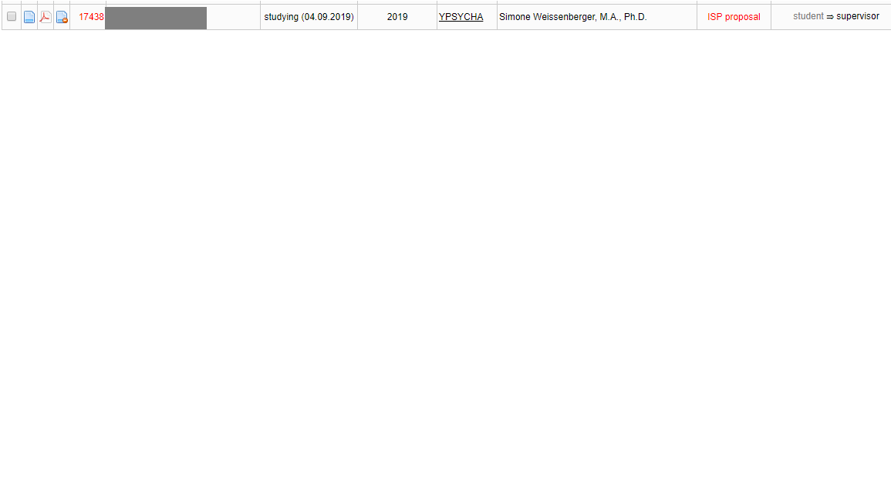

Fig. 7 – State of the plan, Responsibility (plan proposal)

Using the roller menu in the lower part of the screen (Fig. 8), the Supervising Tutor chooses the option **comment of proposal** and uses the text window to add a comment, which subsequently will by displayed in the part of the header State of the plan (see Fig. 7). If the **draft must be returned to the student** for revision or completion, the Supervising Tutor will choose the option send the plan back to student and fill in the instructions for the student in the text window. This text will subsequently be displayed in the last section of the header History of reasons for returning the individual study plan – Fig. 4). The last step is always forwarding the draft plan to the Subject Area Board for evaluation (**Forward the plan to Subject Area Board)**.

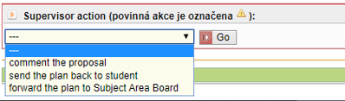

Fig. 8: Supervising Tutor’s options

# Annex 1a: Doctoral study programs in the field of Biomedicine

**Compulsory subjects for all doctoral study programs**

|  |  |
| --- | --- |
| B90003 | English language |
| B90002 | Defence of the dissertation |

Information about the English exam/recognition of the international English certificate can be found in the [faculty website](https://en.lf1.cuni.cz/exam-in-english-for-students-of-doctoral-study-programmes--information) or the website of [Institute for History of Medicine and foreign Languages](https://udl.lf1.cuni.cz/httpudllf1cuniczanglictina-pro-studenty-dsp-phd-1-lf-uk).

If in doubt regarding the subjects, contact your study registrar Ms Eva Charouzdová ([eva.charouzdova@lf1.cuni.cz](mailto:eva.charouzdova@lf1.cuni.cz))

Teachers can record exam results in two ways. Either through the SIS or by recording the exam results in a study record book (index). In case the passing of the course is only recorded in the Study Record Book, the index must be handed to the Study Officer Mrs. Eva Charouzdová ([eva.charouzdova@lf1.cuni.cz](mailto:eva.charouzdova@lf1.cuni.cz) ) so that she can record the result in SIS. And later you can work with it as part of the annual evaluation that takes place at the end of each academic year in SIS.

Biochemistry and Pathobiochemistry<https://en.lf1.cuni.cz/biochemistry-and-pathobiochemistry>

Biology and Cell Biology<https://en.lf1.cuni.cz/cell-biology-and-pathology>

Biomedical Informatics<https://en.lf1.cuni.cz/biomedical-informatics>

Developmental and Cell Biology<https://en.lf1.cuni.cz/developmental-and-cell-biology>

Experimental Surgery<https://en.lf1.cuni.cz/experimental-surgery>

Human Physiology and Pathophysiology<https://en.lf1.cuni.cz/human-physiology-and-pathophysiology>

Imaging Methods in Medicine<https://en.lf1.cuni.cz/imaging-methods-in-medicine>

Immunology<https://en.lf1.cuni.cz/immunology>

Medical Biophysics<https://en.lf1.cuni.cz/medical-biophysics>

Microbiology<https://en.lf1.cuni.cz/microbiology>

Molecular and Cell Biology, Genetics and Virology<https://en.lf1.cuni.cz/molecular-and-cellular-biology-genetics-and-virology>

Neurosciences <https://en.lf1.cuni.cz/neurosciences>

Pharmacology and Toxicology<https://en.lf1.cuni.cz/pharmacology-and-toxicology>

Preventive Medicine and Epidemiology<https://en.lf1.cuni.cz/preventive-medicine-and-epidemiology>

### Subjects/courses for the doctoral study programs in the field of Biomedicine

Please, note, that not all the subjects are held in English.

|  |  |
| --- | --- |
| B90203 | Novelties in biomedical research |
| B90008 | Selected chapters of biochemistry and pathobiochemistry |
| DS001 | Basics of scientific methodology (course takes place in the 2nd Faculty of Medicine) |
| B90019 | Advances in cell biology |
| MPGS0034 | Advances in Molecular Biology and Genetics (course takes place in the Faculty of Science) |
| B90206 | Biomedical informatics and statistics |
| B90246 | Modeling of physiological functions |
| B90277 | Clinical informatics and bioinformatics |
| B90182 | Modeling of biomedical systems |
| B90072 | Physiology regulation system in normal and pathology |
| B90278 | Process modeling in health information systems |
| NPGR029 | Variational methods in image processing |
| NPGR032 | Digital Image Processing in Practice |
| B90015 | Experimental surgery 1 |
| B90016 | Experimental surgery 2 |
| B90044 | Selected issues of endocrinology and metabolism |
| B90276 | How to be the Master and not a Slave of Clinical Research |
| B90209 | Physical interaction of blood circulation and vessel wall and current methods of their examination |
| B90275 | Biomedicine and Biotechnology |
| B90097 | Cellular and Molecular Principles of Immunology |
| B90252 | Novel trends in cardiovascular research |
| B90211 | Biostatistics in cardiovascular medicine. Course for cardiologists & PhD students |
| B90054 | Electrophysiological methods in clinical practice and research |
| B90274 | Applied pharmacokinetics |
| B90248 | Personalized pharmacotherapy |
| CPVL014 | Drugs and Addictions (course takes place in the 3rd Faculty of Medicine) |
| B90247 | Ecotoxicology |
| CVOL0182 | Basics of phytotherapy (course takes place in the 3rd Faculty of Medicine) |
| B90087 | Biophysical methods in medicine |
| B90215 | Practical Medical Physics and Technology  for the Leksell Gamma Knife Radiosurgery |
| B90249 | Imaging methods and systems in medicine |
| MPGS0013 | Advances in microbiology |
| B90005 | Advances in Neurosciences (course takes place in the 2nd Faculty of Medicine) |
| CPGS008 | Basic epidemiology and methodology (course takes place in the 3rd Faculty of Medicine) |
| CPGS014 | Metodologické základy výzkumu kardiovaskulárních nemocí (course takes place in the 3rd Faculty of Medicine) |
| CPGS005 | Introduction to Practical Research Methodology (course takes place in the 3rd Faculty of Medicine) |
| B90189 | Imaging Methods in Medicine |
| B90068 | [The Base of the scientific in work at the ASCR](https://www.avcr.cz/cs/veda-a-vyzkum/vzdelavani/kurz-zakladu-vedecke-prace/) |

Further subjects for doctoral study programs in biomedicine are listed [here](https://dspb.avcr.cz/cs/index.html) or in the faculty website [Předměty pro doktorandy - 1. lékařská fakulta Univerzity Karlovy (cuni.cz)](https://www.lf1.cuni.cz/kurzy-pro-doktorandy)

# Annex 1b: Subjects for other doctoral study programs (apart from Biomedicine)

**Compulsory subjects for all doctoral study programs**

|  |  |
| --- | --- |
| B90003 | English language |
| B90002 | Defence of the dissertation |

Information about the English exam/recognition of the international English certificate can be found in the [faculty website](https://en.lf1.cuni.cz/exam-in-english-for-students-of-doctoral-study-programmes--information) or the website of [Institute for History of Medicine and foreign Languages](https://udl.lf1.cuni.cz/httpudllf1cuniczanglictina-pro-studenty-dsp-phd-1-lf-uk).

If in doubt regarding the subjects, contact your study registrar Ms Eva Charouzdová ([eva.charouzdova@lf1.cuni.cz](mailto:eva.charouzdova@lf1.cuni.cz))

Teachers can record exam results in two ways. Either through the SIS or by recording the exam results in a study record book (index). In case the passing of the course is only recorded in the Study Record Book, the index must be handed to the Study Officer Mrs. Eva Charouzdová ([eva.charouzdova@lf1.cuni.cz](mailto:eva.charouzdova@lf1.cuni.cz) ) so that she can record the result in SIS. And later you can work with it as part of the annual evaluation that takes place at the end of each academic year in SIS.

## Addiction: Specialization in Health Care

|  |  |
| --- | --- |
| B90219 | Introductory training to Addiction Science Studies |
| B90220 | Research Designs and Methods in Addiction Science |
| B90221 | Addiction Theories |
| B90222 | Research Career and Conduct |
| B90223 | Advancing Scientific Skills |
| B90224 | Practical approach to Data Analysis I |
| B90225 | Practical approach to Data Analysis II |

<https://en.lf1.cuni.cz/phd-study-program-in-addictology>

## Bioethics

|  |  |
| --- | --- |
| B90029 | Philosophical methodology |
| B90030 | History of philosophy |
| B90232 | Reading of Philosophical Texts |
| B90233 | Ethics of Genomics and of Beginning of Life |
| B90234 | Ethics in Neurology and Neuropsychology |

<https://en.lf1.cuni.cz/bioethics-study>

## Medical Psychology and Psychopathology

|  |  |
| --- | --- |
| B90250 | Medical Psychology and Psychopathology I |
| B90075 | Medical Psychology and Psychopathology II |
| B90036 | Medical Psychology and Psychopathology III |
| B90158 | Medical Psychology and Psychopathology IV |

<https://en.lf1.cuni.cz/medical-psychology-and-psychopathology>

## History of medicine

|  |  |
| --- | --- |
| B90126 | Somatology (compulsory for Master graduates in humanities) |
| B90127 | Methodology of Historical Sciences (compulsory for graduates in science and biomedicine) |
| B90131 | Lectures and seminars in the history of medicine (compulsory) |
| B91967 | Seminar in the history of medicine (compulsory) |

<https://en.lf1.cuni.cz/phd-students-of-history-of-medicine>

## Experimental and clinical oncology

|  |  |
| --- | --- |
| B90280 | Experimental oncology |
| B90281 | Clinical oncology |

<https://en.lf1.cuni.cz/experimental-and-clinical-oncology>

## Nutritional and Metabolic Sciences

|  |  |
| --- | --- |
| B90226 | Basic genetic for medicine, genetic predispositions and gene-environment interactions for Ph.D. programs |
| B90227 | Aplicated Dietology for GIT Diseases |
| B90228 | Research out of the lab for Ph.D. programs |
| B90229 | Clinical Osteology with an aspect on scientific nutrition |
| B90235 | Statistics, Quantitative and Qualitative Research |
| B90236 | Scientic principles of enteral and Parenteral Nutrition |
| B90237 | Intensive metabolic care department |
| B90238 | Using of plants in the Science and Toxicology |
| B90239 | Overview of Clinical Dietology and Nutrition (only for students who did not complete the Mgr. Studies in Nutritional and Metabolic Sciences) |
| B90240 | Psychology, Psychiatry and Communication in Nutrition with an appeal to nutrition issues (only for students who did not complete the Mgr. Studies in Nutritional and Metabolic Sciences) |
| B90241 | Applied principles in gerontology and geriatrics |
| B90242 | Interaction of Drugs and Food for Ph.D. Programs |
| B90243 | Intervention of metabolic diseases in practice |
| B90244 | Clinical seminar 1 |
| B90245 | Clinical seminar 2 |

<https://en.lf1.cuni.cz/nutritional-and-metabolic-sciences>

Parasitology<https://en.lf1.cuni.cz/phd-degrees-in-parasitology>

Cardiovascular Science<https://www.lf1.cuni.cz/kardiovaskularni-vedy>

1. The students of the Subject Area Board of Experimental Surgery will complete and outline in **the progress on the doctoral dissertation** elaborating on the following points:

   1. Introduction to the probelm

   2. Hypothesis and aims of the thesis

   3. Planned methodology

   4. Planned method of organization and acquisition of experimental data

   5. Schedule for the progress of the work (year by year)

   6. Reference literature
2. In case of study programme History of medicine only two subjects are prescribed in the ISP, the third subject is chosen from two options given by the accreditation depending on the profile of their previous studies (see information on page 13).