INSTRUCTIONS FOR EVALUATION
This text gives a detailed description of particular steps of evaluation, which are completed with visuals for more clarity. These visuals are only meant to demonstrate how particular things are shown in the application. As minor changes are still in progress in the application, the current state may be slightly different from the visuals enclosed.

1. Registration for SIS
At the address https://is.cuni.cz/studium you can register for SIS, using your CAS login and password. For detailed information about registration in SIS and possibility of getting a new CAS password, see https://cuni.cz/UKEN-134.html
You are strongly requested to make sure as soon as possible that your SIS access data are up to date and functional. If you do not possess the Charles University student/employee card, please visit the Charles University Card Centre.
In SIS, you choose the application  Individual Study Plan for PhD students and see the line with information about the studies – see Fig. 1. After clicking on the icons in the left part (the red arrow), the original approved plan (curriculum) will be seen (a PDF file with the original curriculum and the detail, where further obligations ensuing from the previous approved Annual Evaluation have been entered ). In the right-hand part with the same icons (the blue arrow in Fig. 1), the previous approved Annual Evaluation is displayed (for students in their second or higher year of studies).
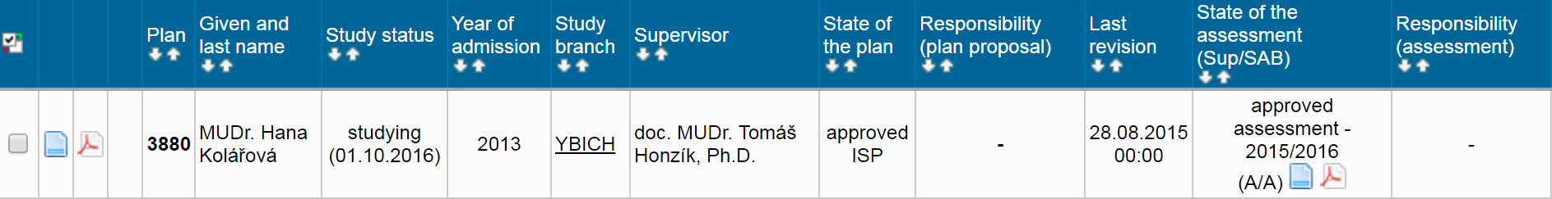

Fig. 1: Basic information about the studies

For more clarity, we chose a clearly arranged visualization of the headings in both study plans (curricula) and annual evaluations. The data is arranged in particular groups; the details will be seen after clicking on the icon with the symbol plus (Fig. 2).
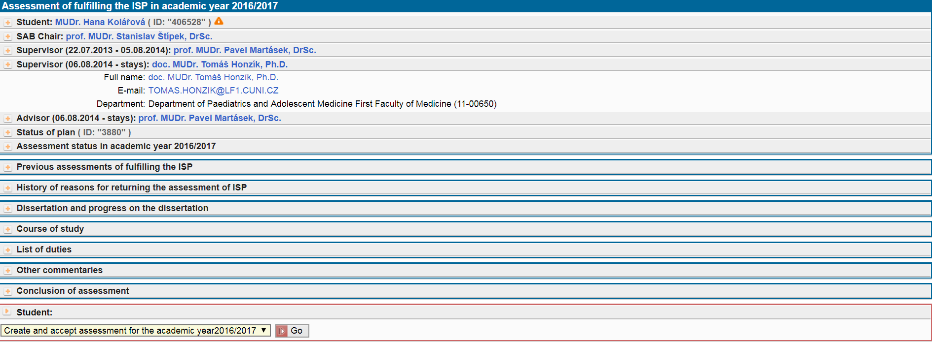
Fig. 2: Heading of detail of the curriculum (study plan)

2. Setting up a new Annual evaluation of fulfilling the ISP (thereinafter “AE”)
The fastest way to set up an AE is clicking on detail (the blue arrow in Fig. 1), which will take you to the form. At the end of the form you can find a possibility to “Create and take the annual assessment over 20xx/20xx” (Fig. 3).
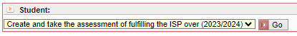
Fig. 3: Setting up an Annual Evaluation
Students compiling their first evaluation have to proceed via the Details of approved plan (the red arrow in Fig. 1), and then the button Assessment of fulfilling the ISP will appear at the bottom of the screen below the list of obligations set by the plan 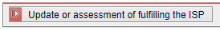. A click on this button will take you to the AE page, and at the very bottom the option of setting up a new AE will be offered (Fig. 3).
The heading of the AE is similar to that of the study plan. Details of a certain part will be displayed after clicking on the respective plus button. In Fig. 4 you can find the survey of previous evaluations, including any changes in the Supervising Tutor and/or Consulting Tutor.
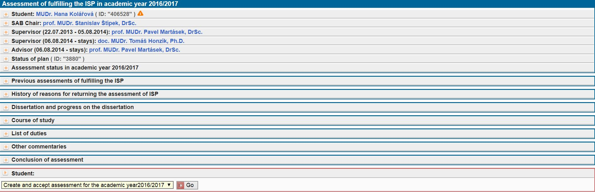
Fig. 4: Heading of the current AE, display of previous AEs, possible changes in the Supervising Tutor and/or Consulting Tutor

3. Entering a progress on the doctoral dissertation
(in case it has not yet been properly entered in ISP)
The obligation to insert a progress on the doctoral dissertation applies to all students who do not have the work on the dissertation project scheduled for particular academic years, either directly in the field of progress on the doctoral dissertation or in the field of Course of study. It must be clear from the plan what specific actions you plan to take in which (upcomming) academic year. The plan may not exceed four years.
If you are already studying in an advanced year of study (ie. more than the standard study period + 1 year), the plan must also not exceed the maximum duration of your studies. Plan your studies to be completed as soon as possible.
An annotation of the dissertation can be inserted as a separate attachment to a “Dissertation and progress on the dissertation” field using an icon at the left side (Fig. 5). The grey icon of a floppy at the right side will become blue and using it the attachment can be opened.
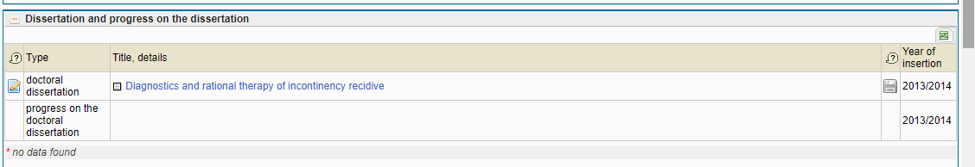
Fig. 5: Entering an annotation on the doctoral thesis

4. Editing the documents for evaluation and modification of the study plan
An obligatory part of any Annual Evaluation is:
- insert commentary for duties of type: progress on the doctoral dissertation (fill in a comment on the progress in preparation of the dissertation during the past academic year)
- insert summary to assessment of fulfilling the ISP (fill in the final summary for the past academic year)
In Fig. 6 the compulsory comments are marked with an asterisk (*). The options are placed at the bottom of the form. You must choose one and press “Go”.
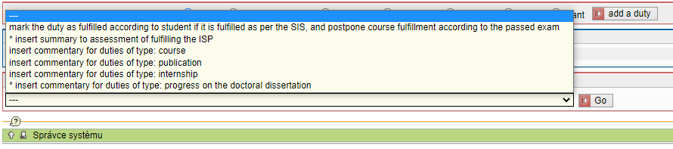
Fig. 6: Options of comments
Of the following steps, you will complete those that are relevant to the current academic year:
- match an obligation in ISP to the passed subject in SIS
- add another subject taught at Charles University to the study plan (labelled as “course”)
- add a subject taught at other universities or provided by Academy of Sciences of the Czech Republic or another organization (labelled as “course description”)
- match publications in the ISP to the record imported from the OBD system
- possibility to upload files (published articles, posters or abstracts from conferences)
- match a stay/placement in the ISP to the record of the stay/placement in the SIS – entered in the SIS in the module Internships
- add any other types of obligations
- add synoptic comments to particular types of obligations (see options in Fig. 6)
- place the application for deleting the subject, or “course description” (see below) from the plan
Working with particular study obligations will vary depending on their type. If you entered an obligation in an inappropriate category, within the annual evaluation you shall ask for the deletion and enter the new, correct type of obligation.
Subject (within Charles University) - is completed by some form of control of study progress (credits, exam, etc.), and have its match in the recorded subjects, which are printed out in the Diploma Supplement after the studies are completed. After fulfilling the study obligations, these must be matched to the records in SIS (see below). If you do not pair the completed requirement with the appropriate course in SIS, the AE will be returned to you by the supervising tutor.
Course description (a subject beyond Charles University) are completed by some form of control of study progress (credits, exam, etc.), and have their match in the recorded subjects, which are printed out in the Diploma Supplement after the studies are completed. Subjects taught at other universities are entered by the study registrar, following provision of the relevant documents. After fulfilling the study obligations, these must be matched to the records in SIS (see below).
Training - a course (e.g. IPVZ, etc.) that a student takes to broaden his/her expertise.
Publications are imported from OBD (faculty); within the evaluation the students will match a publication entered in ISP to the record imported from OBD; they can enter a file with the text of the publication (if required by the FB – these materials are not public and only serve the internal use of the FB).
Conferences – a file with abstracts or posters from conferences can be entered (if required by the FB – these materials are not public and only serve the internal use of the FB).
Internship (Stays/placements) – students can enter their stay/placement through an application in the SIS  ”Internships”. In either case, please, allow for some delay.
Grant - grant, can be paired with the record of grants registered in the external application Grants and projects
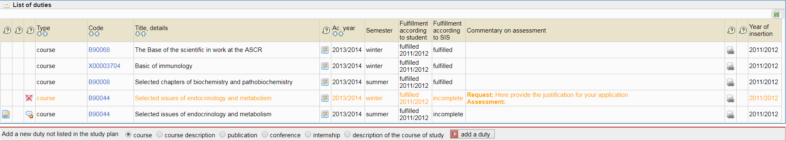
Fig. 7: Survey of obligations, view of matching the subjects, application for deletion of an obligation from the plan
Following text gives a detailed description of the matching of obligations and the meanings of the icons in Fig. 7 (including illustrative pictures and other explanations) for particular study obligations.
Most often you will use the icon (further called “editing icon”) to match the subjects, publications and intership, to insert files to publications and conferences, and to add comments to all types of study obligations.
In study obligations of the type subject and ”course description”, the choice of the above icon will display the options of the subjects passed (see Fig. 8), where you should tick the subject that you want the obligation to match to (if there is a passed subject with the same code in SIS, this has already been marked).
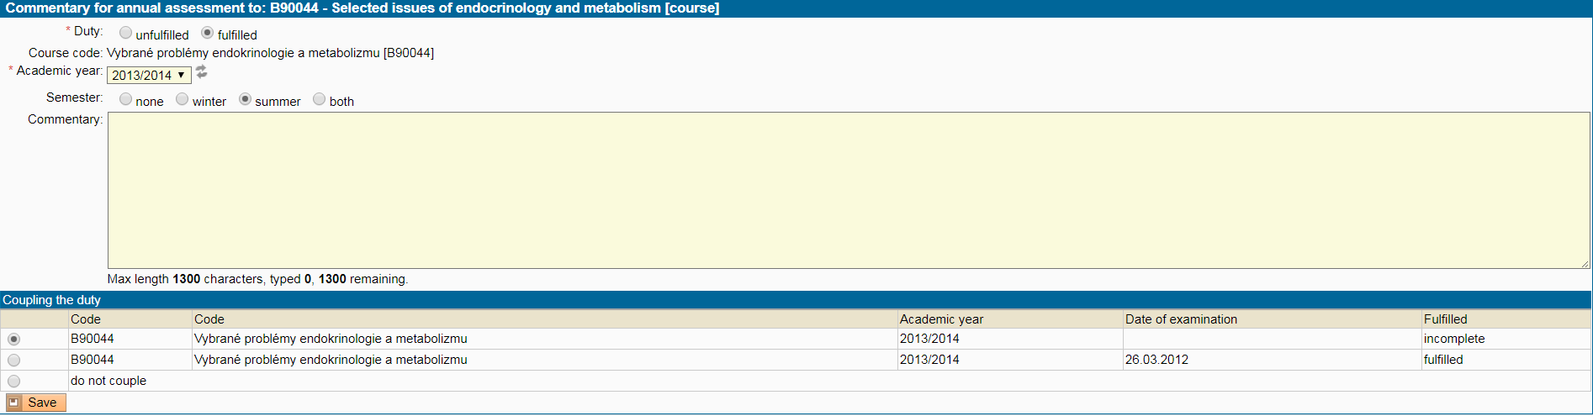
Fig. 8: Matching of subjects
The subjects entered by their code and matched in the past academic years cannot be adjusted again, as shown in Fig. 7 for subject B90068. In the PDF of the draft annual evaluation, the exact date is always shown when the obligation was fulfilled. Remember that a condition for successful pairing of your courses is that the course guarantee (course representative) writes down the result of the obligation electronically in SIS or you need to deliver the proofs of passing the subjects/obligations to your study registrar as soon as possible, so that you can match them in the evaluation. If you are planning the State Doctoral Examination / Discussion on the Dissertation Topic and/or Defence of the dissertation in the next academic year, also enter as obligations the respective subjects from SIS if they have not been included in your ISP yet. The State Doctoral Examination B90001 or Discussion on the Dissertation Topic B90400 and the Dissertation Defence under the code B90002 are displayed in the block above the course of study called "State Doctoral Examination and Dissertation Defence".
In the annual evaluation, it is possible to match, in a similar way, the publications that are entered in the Faculty database OBD. The record of the publication should be entered via the option “Add subsequently an obligation not shown in study plan” (see Fig. 9a+9b) first. The corresponding record can be imported from OBD using the editing icon afterwards. In the case that the publication has not been entered in OBD yet (at the Faculty the ways will vary from unit to unit) or it is shown e.g. within the Academy of Sciences of the Czech Republic, the student will fill in the type and citation of the publication by hand. After entering the publication, it is possible to enclose the relevant file as well.
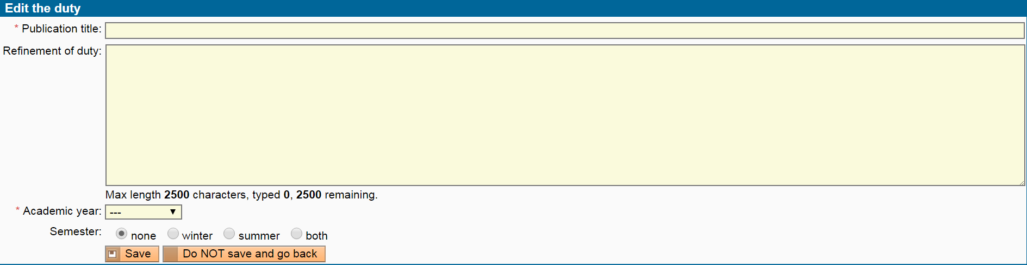
Fig. 9a: Entering a publication
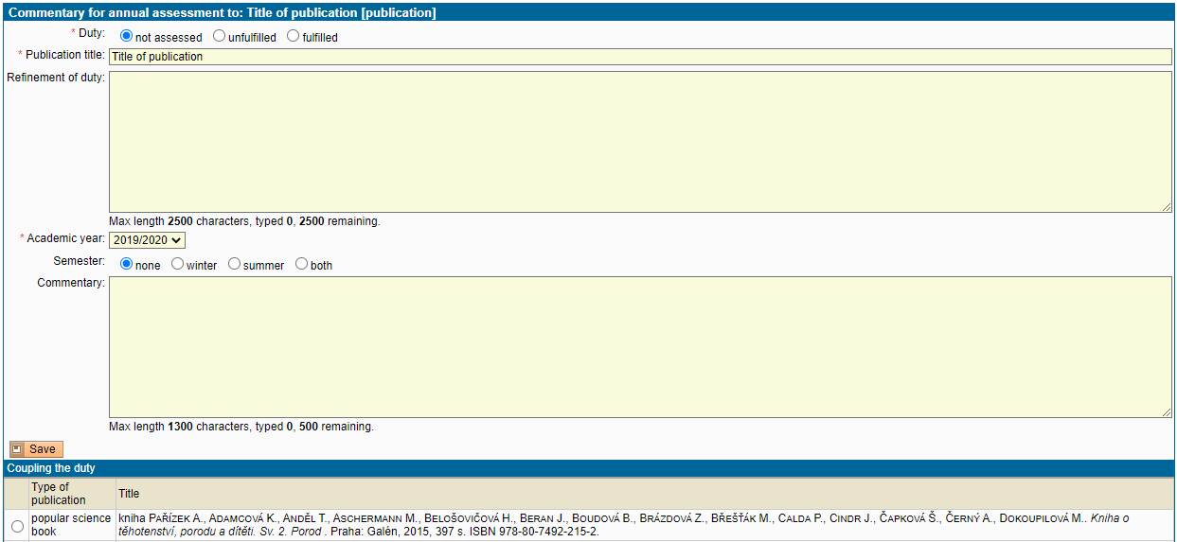
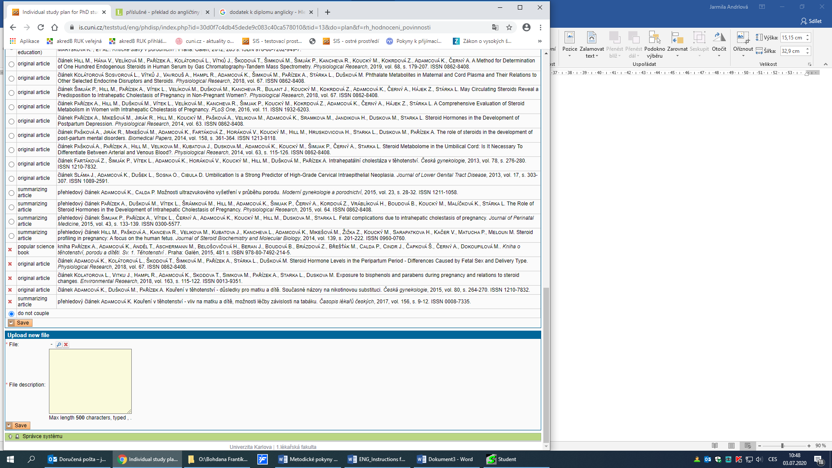
Fig. 9b: Matching a publication to the record in OBD
Information on the OBD system (serving to record of publication activity)
Into the OBD system, only such publications can be entered that were created within studies or employment at the First Faculty of Medicine of Charles University, and if affiliations are mentioned in the publication, Charles University – the First Faculty of Medicine must be shown as your institution (according to the Dean’s Order number 6/2018). If any other institution (e.g. Academy of Sciences, Institute of Clinical and Experimental Medicine, etc.) is shown, such a paper cannot be entered in OBD.
Abstracts, posters and lectures are not recorded at the First Faculty of Medicine. The way of entering the publications is really diverse within the First Faculty of Medicine and it may vary from unit to unit.
More information can be found in the Rector's Directive No. 40/2021 as amended by Rector's Directive No. 26/2023 . If necessary, you can contact Ms Jana Homolková at the Institute of Scientific Information, First Faculty of Medicine Charles University and General University Hospital (jana.homolkova@lf1.cuni.cz, 224 96 5618).
Internships
The prerequisite is entering the record of the stay/placement into SIS through
the module Internships . The module for recording of the stays/placements can be found after you log in to SIS, array Utilities, icon Internships .
To enter the record of a stay/placement, choose the array New (Fig. 10). The field Unit suggesting to record the stay is filled in automatically by the system with the information that is recorded about you in the system Student (by study registrars). Only the fields Type (of stay) and Country are set as obligatory, and in either case you choose the data from a pre-set numerical array. School abroad is an optional field; if your stay/placement took place at a scientific institution, please mention this fact in the field Note. Fill in, please, first of all the fields concerning the dates of your departure and return from the stay. Without this information your stay cannot be duly recorded.
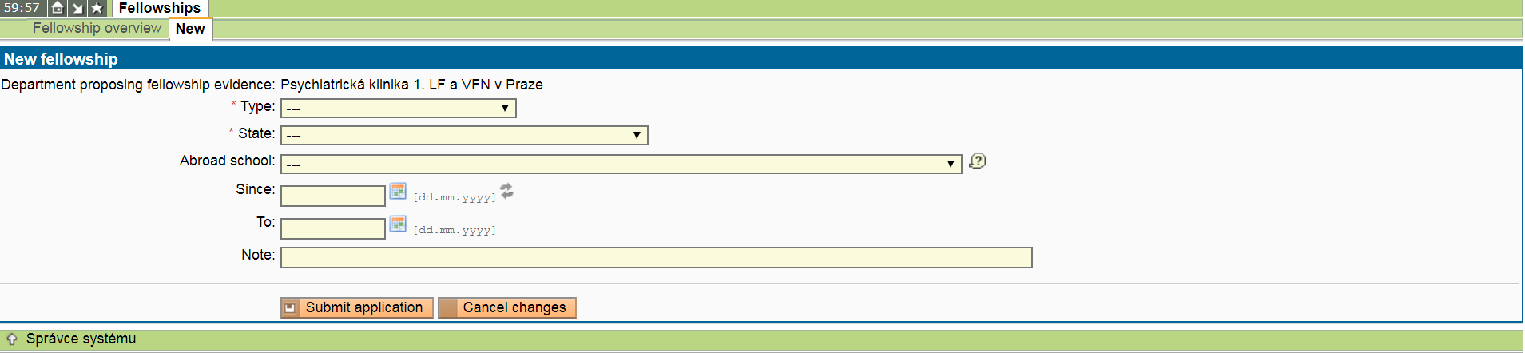
Fig. 10: Module for records of study stays
If the stay/placement was entered in the ISP earlier and now will only be matched, the original title of the stay will be overwritten with the data recorded in the numerical array. Please notice that the data in the column State of application are not essential so far.
You are requested to pay much attention to the recording of stays, as this is one of the particulars strictly observed by the Rector’s Office of Charles University. Data of international travel of outgoing students is also a monitored item in international evaluations of universities.
Meanings of other icons in Fig. 7:
right at the end of the line with data on obligation, after a click on the icon the information about interconnection with the passed subject in SIS (see Fig. 7), matched publication or stay will be displayed.
right at the end of the line will appear in the case if a file is enclosed with a publication or conference (see Fig. 11). If no file is enclosed with these types of study obligations, the icon is black-and-white. The enclosed files are not public. Only the supervising tutors and members of the FB have the right to inspect and download them. If there are more files the icon will change (). A file to be enclosed with a study obligation can be entered after choosing the editing icon.

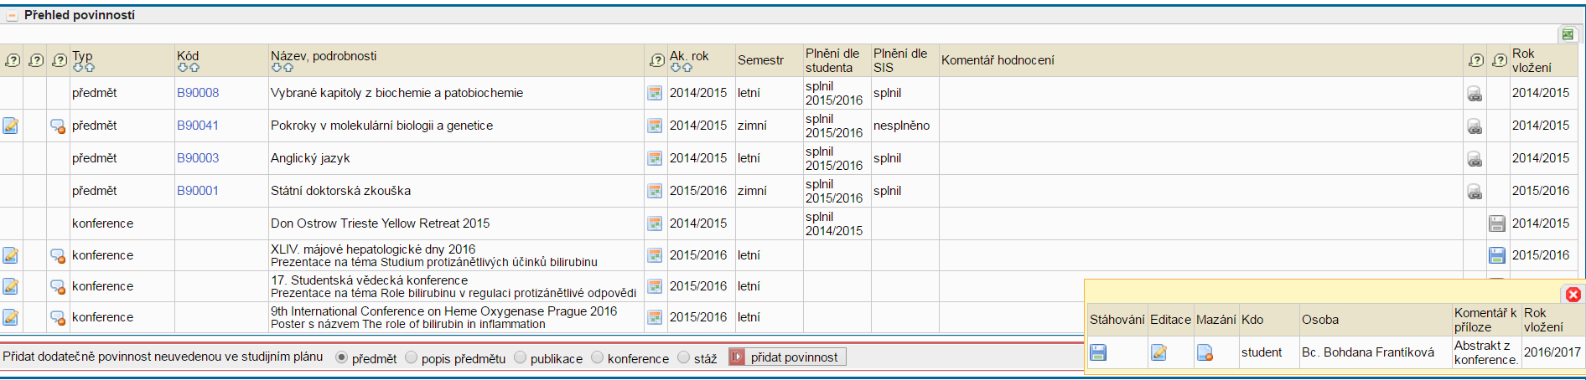
Fig. 11: Displaying of files
deleting a comment of an obligation, cancelling of mismatching of subjects or publications
deletion of an obligation added within the current annual evaluation
proposal to delete a subject from the study plan, previous agreement with the Supervising Tutor is always necessary. After a click on this icon, the student will write the grounds for his/her requirement – see the orange text in Fig. 8. Deletion of a subject from the plan is approved by the Supervising Tutor. In the PDF of the Annual Evaluation this will be manifested by a different typeface.
cancellation of application to delete a subject from the study plan, or correction of mistakes or misprints.
will show in a new column for the original year when the obligation should have been fulfilled, if the planned fulfilment of the obligation was changed (see Fig. 12)
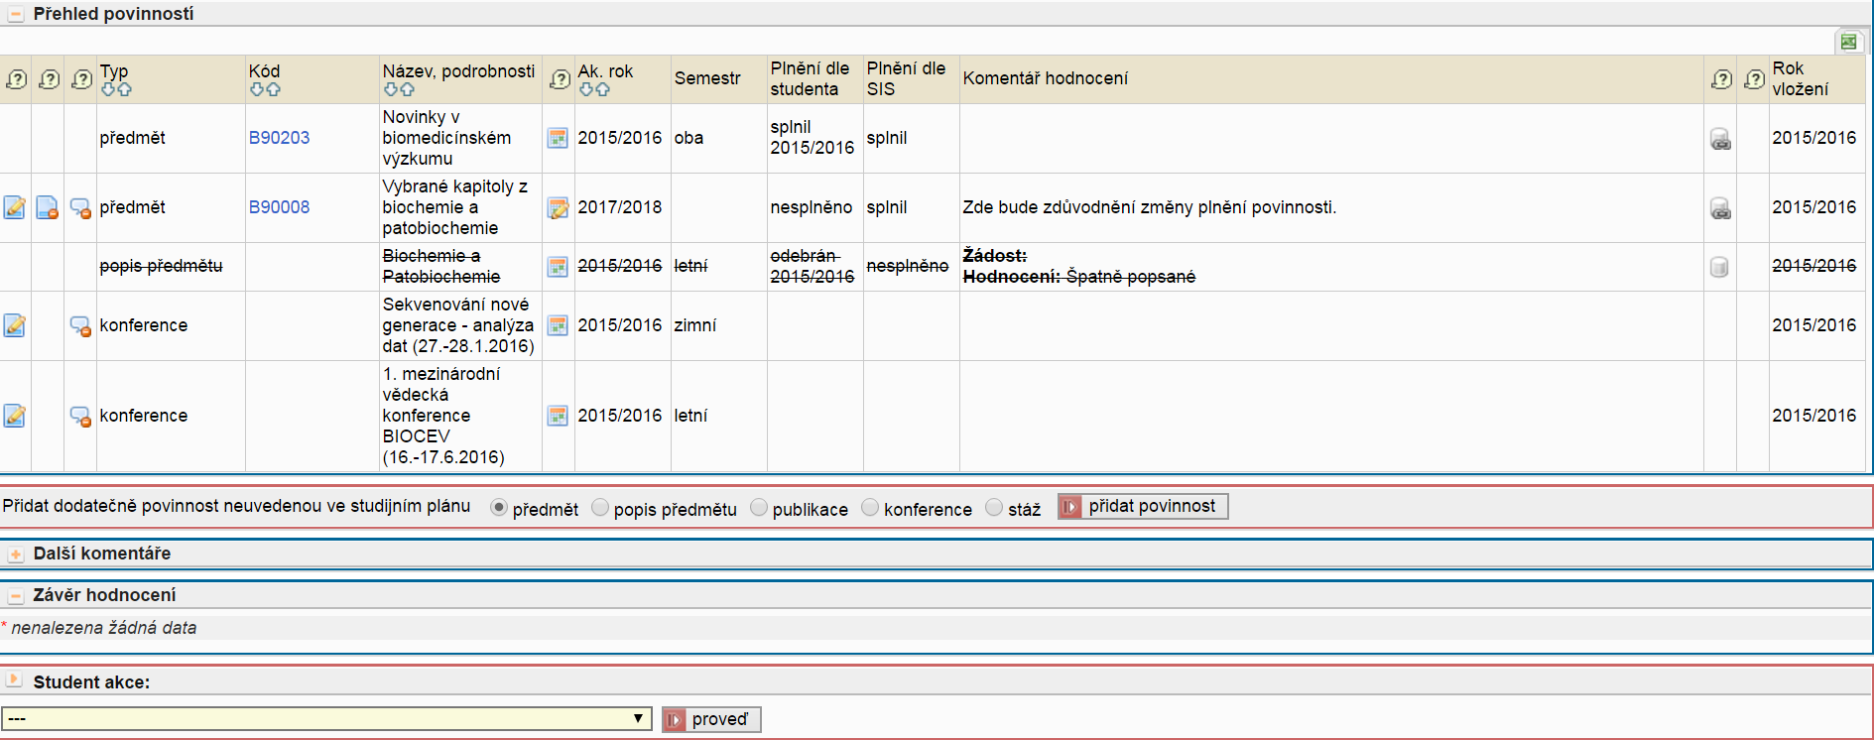Fig. 12: Change in the planned year of fulfilment

5. Further details
Do not enter a publication until it comes out or is at least in print and all the data is known. If you are planning publications for the next academic year, we recommend that you give the information within the text of the student’s final comment (see below), summarizing the activities in the past academic year and at the same time adding the plan for the next academic year.
If you do not have any publications available in OBD (they have affiliation to another organization or have not been entered to OBD as the schedule of entering records to OBD does not consider evaluation of doctoral studies yet), state precisely the type of the publication (usually a journal article) and fill in the full citation in the field Refinement of duty.

6. Summary of fulfilment of ISP for the past academic year, forwarding the evaluation to the Supervising Tutor
The comments concerning preparation of the dissertation thesis will be displayed in the relevant part of AE (see Fig. 13 a). You will enter the comments through the line Student action – enter comments for the group of obligations as the type: progress in preparation of the dissertation thesis (see Fig. 13 b).
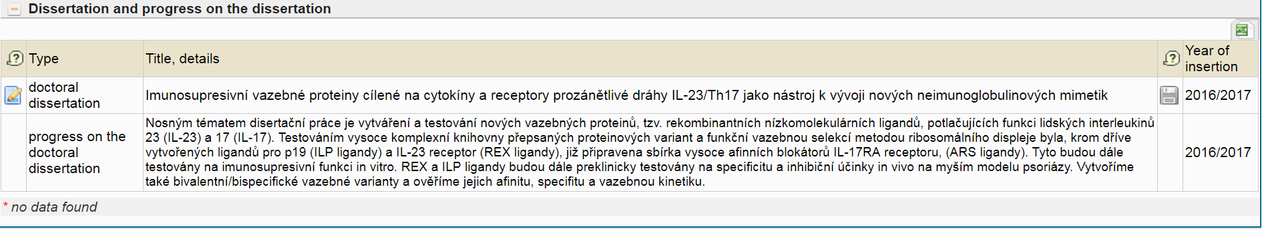
Fig. 13 a: Dissertation thesis – view of comments concerning preparation
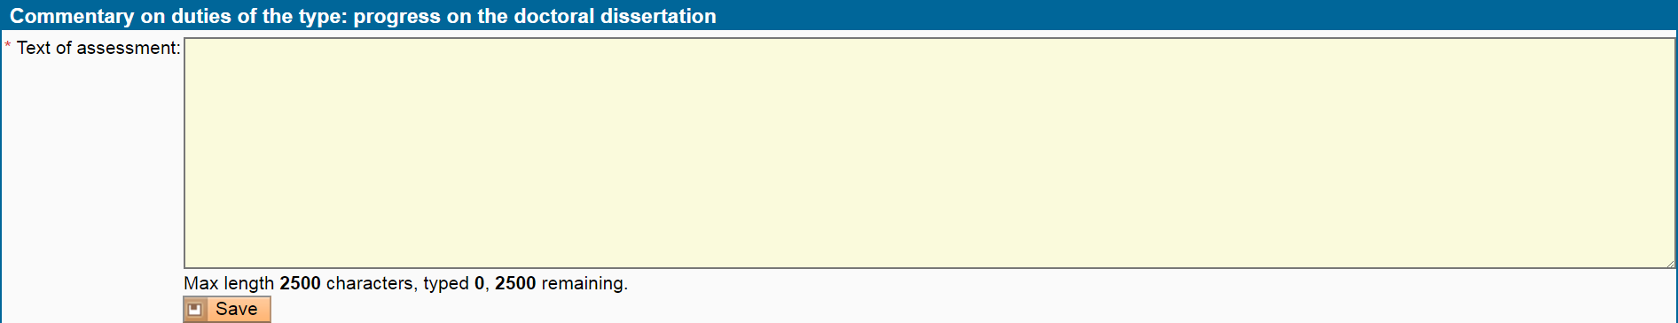
Fig. 13 b: Dissertation thesis – inserting comments concerning preparation
If you fill in the summarizing comments for other types of study obligations, they will be displayed in the part Other commentaries. The summarizing comments given in the part Conclusion of assessment (see Fig. 14) will subsequently completed with the statements of the Supervising Tutor and the Field Board.
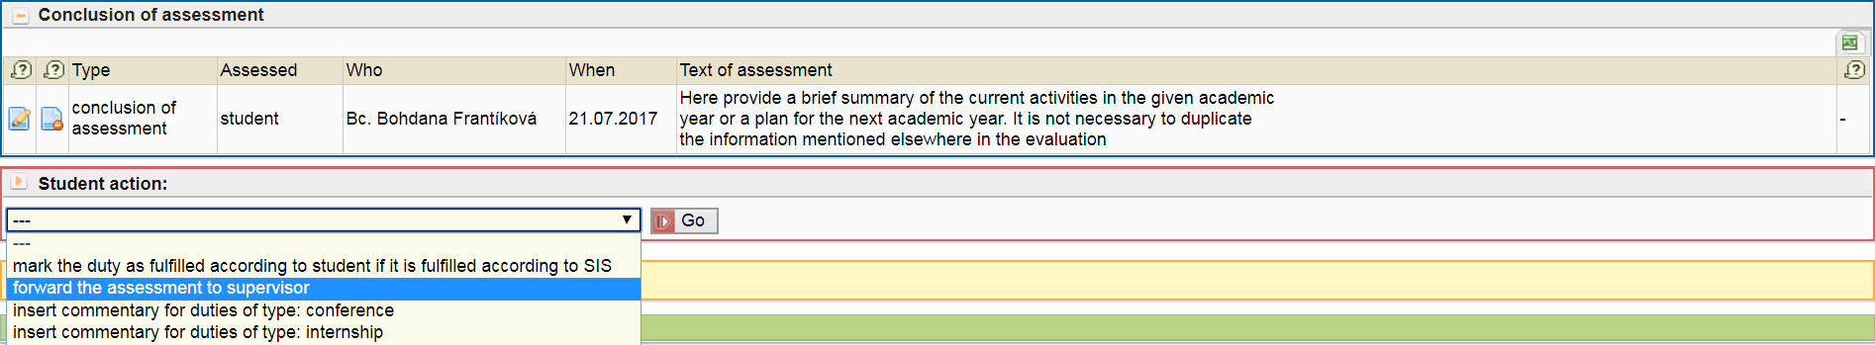
Fig. 14: Summarizing comments, forwarding to the Supervising Tutor
Use the first option from the menu in Fig. 14 (“mark the duty as fulfilled according to the student, if it is fulfilled according to SIS”) for automated addition of the text “fulfilled” where relevant (e.g. stays, publications).
Eventually check everything again, and possibly look at the PDF of the draft AE, indicated by an icon (in the section “Assessment status in academic year 20xx/20xx”). Forwarding of the prepared documents to the Supervising Tutor for inspection, his/her own evaluation and subsequent approval by the FB will be effected by choosing the relevant line from the options in Fig. 14.
The Supervising Tutor will be informed of passing the responsibility through an e-mail. He/she may well require some specifications or additional data. In such a case, responsibility will be transferred back to the student, who will be informed through an e-mail, and information about the Supervising Tutor’s other requirements will be clearly arrayed in the lower part of the heading of AE.
Similarly, the chairperson of the FB can return the evaluation for completion as well.
Therefore do not delay to add the required data so that the FB have enough time to evaluate the completion of your ISP.

