Guidelines - Electronic enrollment
For students enrolling to 2nd, 3rd,4^{th,} 5th and 6th year of studies

Enrollment is going to be electronic in upcoming academic year 2021/2022
- Two steps are needed:

  - Validation request
  - Registration of eligible and compulsory subjects

It is important that you follow (and put in practice) all of the following steps one after another without jumping ahead!

- Make sure that you have fulfilled all of your study obligations and that your SIS is completed
  - Summer clerkship is also considered as a compulsory subject!
  - State exams are excluded from this – you may request validation of your results regardless whether or not you have passed your state exams in that particular academic year.

- Request a validation of your study results. You can do that in your SIS in the SUMMARY OF EXAM RESULTS, option VALIDATIONS. Electronic notification will be sent to study department which will confirm or decline your validation in the SIS (this process usually takes couple of days before it can be confirmed by the study dept.).

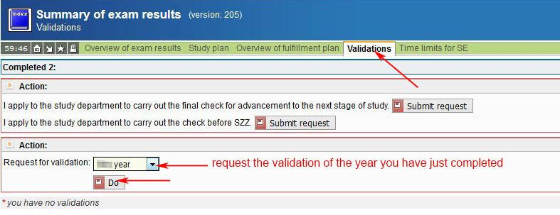

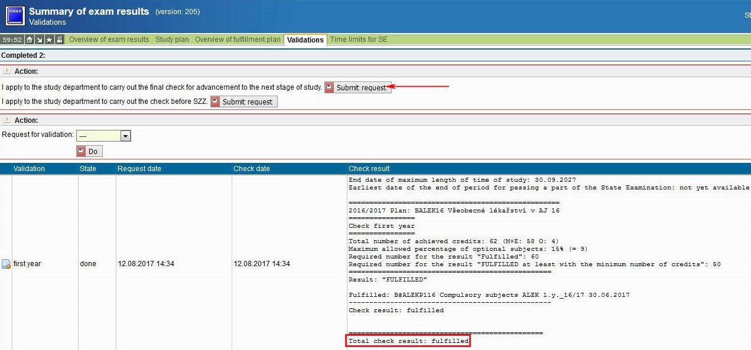

- Study groups remain the same. Students don't get to choose their study groups in upcoming academic year 2021/2022. Since there are only 4 groups in the 4th year, groups 3055 and 3056 will be equally divided into these four groups. Groups 5051 and 5052 will be 6051. Groups 5053 and 5054 will be 6052.
  - By this time, you should be able to see the validation as confirmed in the Examination Results section in your SIS (to be able to see it you will need to set the system setting to academic year 2021/22 through the SETTING button in the top green task bar of the SIS main screen)
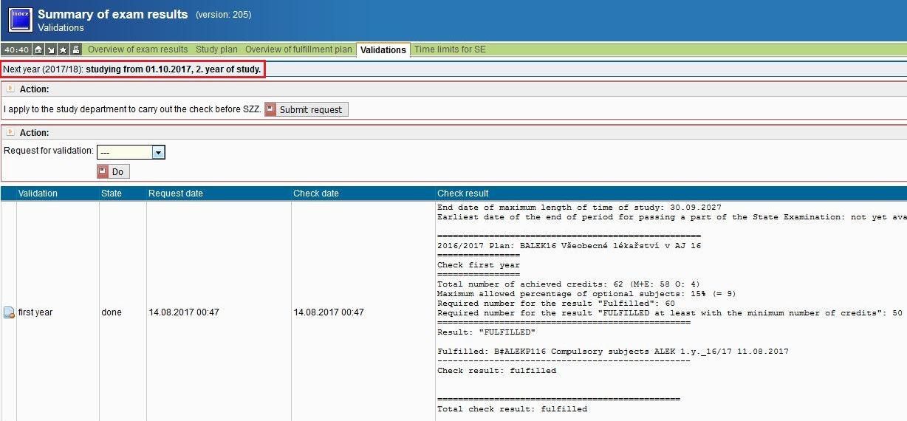
- Enroll for the elective subjects for the upcoming year.
  - The preliminary enrollment of ELIGIBLE SUBJECTS for winter semester for academic year 2021/2022 is 20.07.2021 (from 9:00 am) to 01.10.2021 for students who fulfilled all study obligations of the academic year 2020/2021.
  - Standard enrollment of ELIGIBLE SUBJECTS for winter semester for academic year 2021/2022 will be from 20.09.2021 (from 9:00 am) to 01.10.2021.
  - Summer semester – enrollment of ELIGIBLE SUBJECTS will be open later in the academic year, from 01.02.2022 (from 9:00 am) to 21.02.2022 (to 23:59).

Detailed information including the guideline and list of available eligible subjects for academic year 2021/22 may be found here:
  - https://en.lf1.cuni.cz/eligible-subjects-academic-year-20192020
  - in terms of enrollment of the eligible subjects please note following:
    - BE AWARE THAT "APPROVED SUBJECT" IN THE SYSTEM DOESN'T MEAN THAT THE SUBJECT IS ENROLLED. AFTER THE SUBJECT IS APPROVED YOU HAVE TO GO BACK TO THE SECTION "ENROLL MY OWN", PUT A CODE OF THE SUBJECT AND THEN CONFIRM ENROLLMENT OF THE SUBJECT!

- Enroll for the compulsory subjects for your next year of studies.
  - Enrollment of the compulsory subjects will be from 20.09.2021 until 01.10.2021.
  - Do not forget to do so for both winter and summer semester subjects.
  - How to do it – picture guideline, may be found here: http://www.lf1.cuni.cz/document/41976/zapis_PP+PVP_en1.pdf

- Make sure your personal details in the SIS are correct and up to date. Do that in the Personal Data section in your SIS (through the data change icon in the top green task bar)
